# **Drought Monitoring**

## **Products**

Those products are contain in the drought bulletin that is generated by month,

### **Percentage of Average**

An example of the products: Precipitation in percentage of average of May 2022.

Data source link: <http://iridl.ldeo.columbia.edu/SOURCES/.NOAA/.NCEP/.CPC/.CAMS_OPI/.v0208/.mean/.prcp/Y/-40/0.5/40/GRID/X/25/0.5/55/GRID/T/(%20May%202020)/VALUES/31/mul/>

The applied formula is: (X_i/M)*100)

X: Given month cumulative of the year i

M: Climatology of the Month (average from 1981-2010)

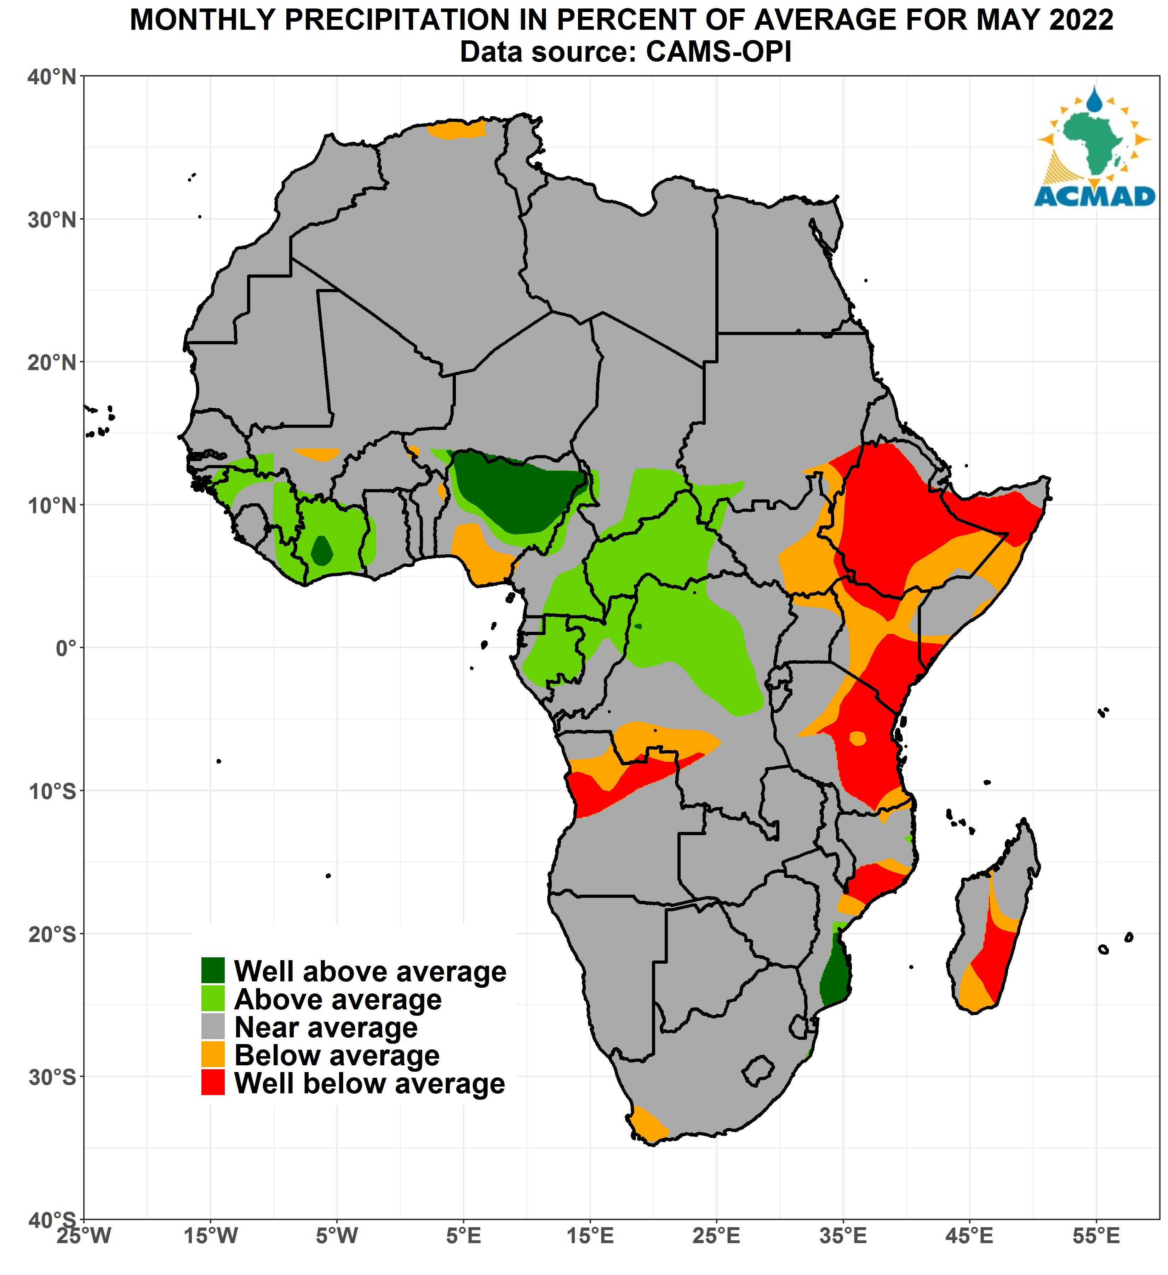

### **Soil Moisture Anomaly**

An example of the products: Soil Moisture Anomaly for May 2022.

Data source link: <http://iridl.ldeo.columbia.edu/expert/expert/SOURCES/.NOAA/.NCEP/.CPC/.GMSM/.w/Y/-40/0.5/40/GRID/X/25/0.5/55/GRID/T/(%20May%202020)/VALUES/>

The applied formula is: (S_i -M)

S_i: Given month soil moisture of the year i

M: Climatology of the month (average from 1981-2010)

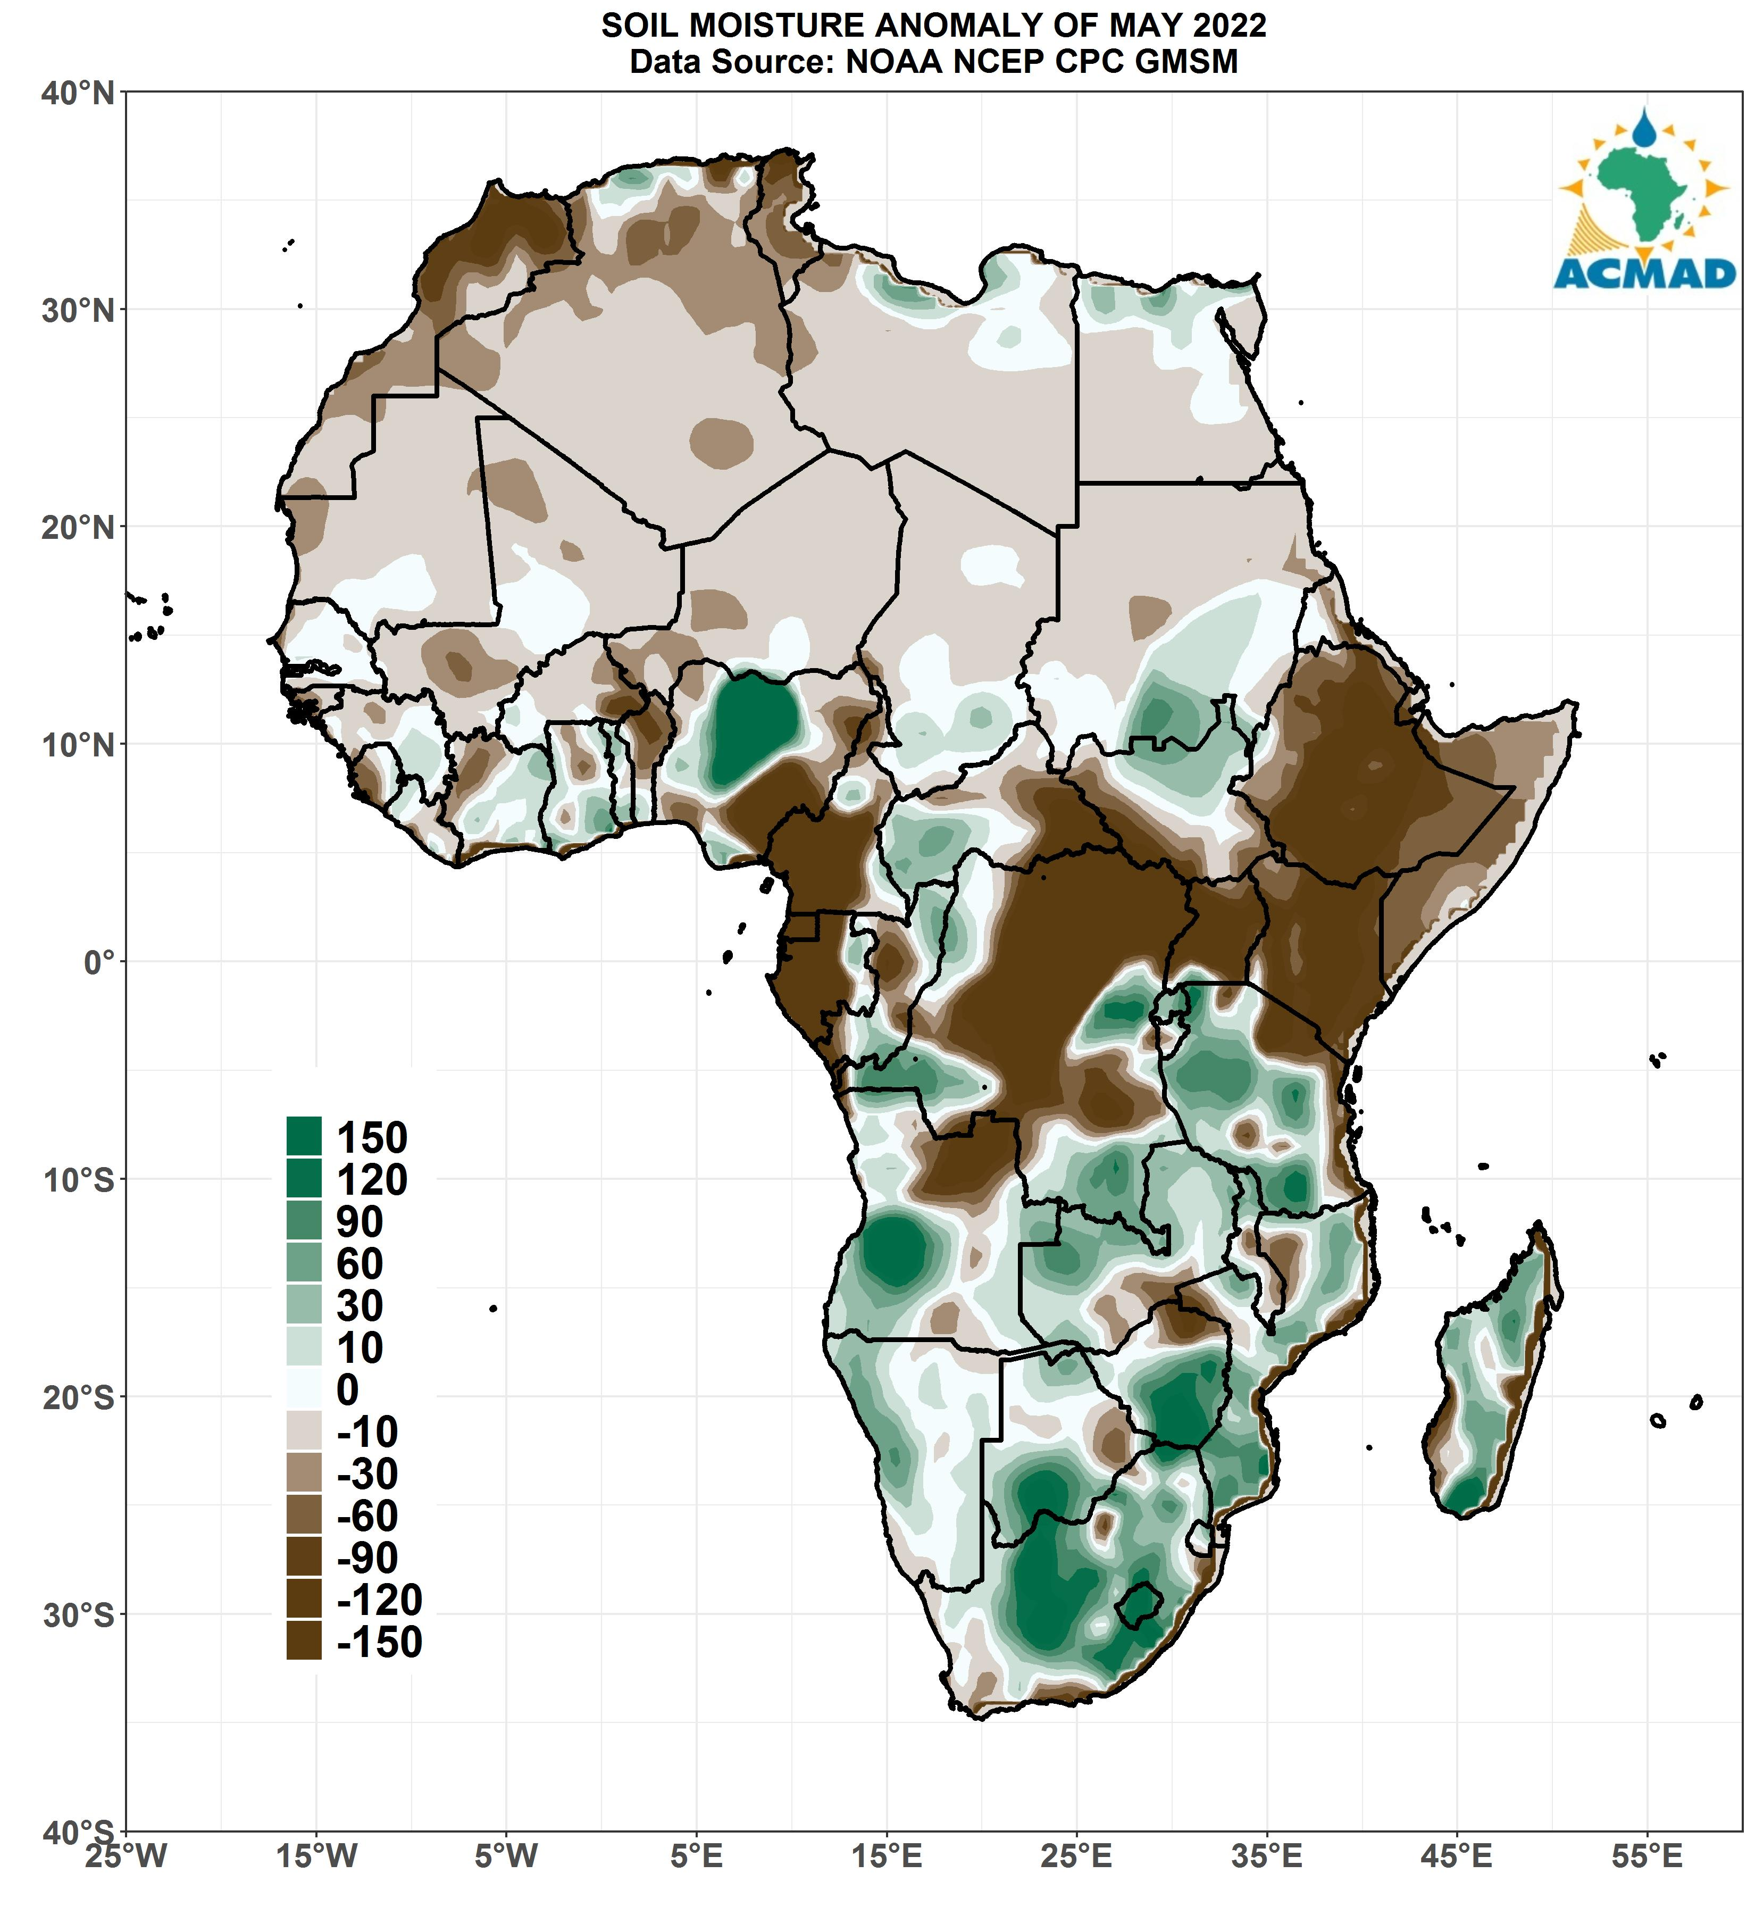

### **Standardized Precipitation Index (SPI)**

An example of the products: SPI for March-April-May 2022.

Data source link:

<http://iridl.ldeo.columbia.edu/SOURCES/.IRI/.Analyses/.SPI/.SPI-CAMSOPI_3-Month/X/-25/0.5/55/GRID/Y/-40/0.5/40/GRID/T/>

The applied formula is: (X_i -M)/SD

X_i: Given month precipitation cumulative of the year i

M: Climatology of the month (average from 1981-2010)

SD: Standard deviation of the month (from 1981-2010).

We normalize the SPI using percentage of average correction principle

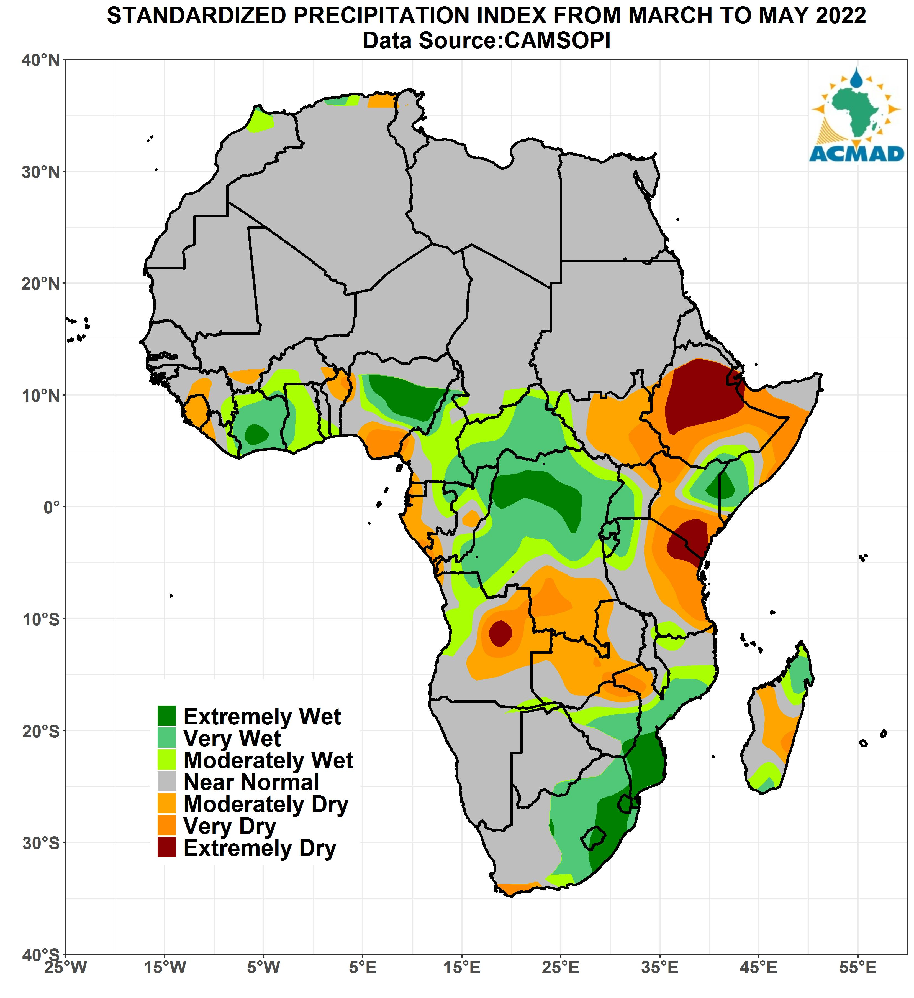

### **Drought Index**

By combing the three parameters above we come we this map that show the state of drought

